

Figure S1. Alignment between 30F and cox1 sequences of rotifers on Genbank. Sequence without matching nucleotides with 30F were not shown here. The 5 degenerated sites in 30F covered most variable sites in the region that 30F paired with. The 4th site (from right to left) in 30F is “T”, while this site is mostly composited by “A” or “T” in the cox1 sequence of rotifer. No mismatch was found at the 3’-end.

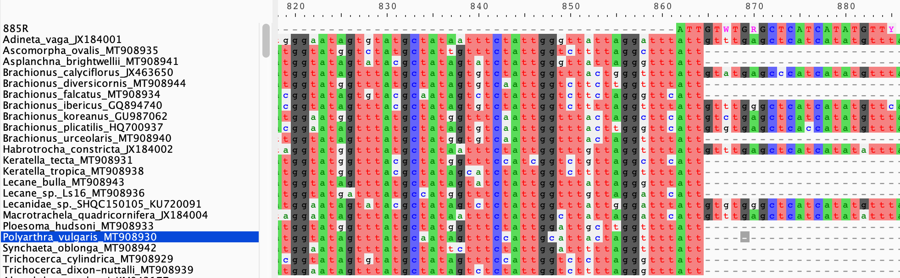

Figure S2. Alignment between 885R and cox1 sequences of rotifers on Genbank. Sequence without matching nucleotides with 885R were not shown here. No mismatch was discovered at the 3’-end, and the 3 degenerated sites in this primer can deal with most variation within its’ paired region.